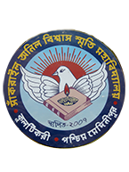
SANKRAIL ANIL BISWAS SMRITI MAHAVIDYALAYA
Affiliated to Vidyasagar University
Accredited by NAAC
AT & P.O- KULTIKRI, DIST- JHARGRAM, PIN-721135 (W.B.)

Memo No....................................... Date: 26/11/2020

NOTICE
It is hereby notified that B.A (HONS & GEN) Part-II Form-Fillup will be held on 28/11/2020 (from 11:00 a.m to 1:00 p.m) .
Students are hereby advised to follow the COVID-19 norms strictly. No students will be allowed inside the college campus without proper mask.

Form Fillup fees for Hons & Gen (Regular) Rs. 180/-
Form Fillup fees for Hons & Gen (Compartmental) Rs. 150/-

Note:- Every student must bring their last Admission money receipt .

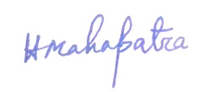
Teacher-in-Charge
